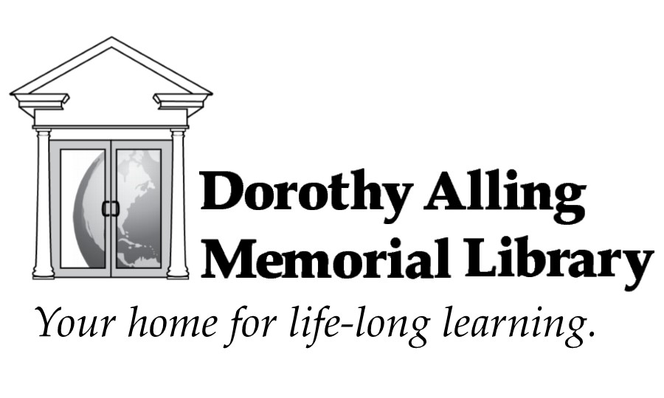

STRATEGIC PLAN 2019-2023

Plan completed December 2018
Approved February 11, 2019

Contents
- Thank you
- How We Gathered Information
- Town of Williston: A Synopsis
- Dorothy Alling Memorial Library: A Synopsis
- Strategic Goals: Our Focus For the Future
- Charts and Statistics
- For More Information: Sources and For Further Reading

Thank you
We wish to thank the community of Williston for their continued support of the Dorothy Alling Memorial Library. This plan could not have been done without the help of those who gave up time to complete our survey, attend meetings and to create this plan from the wealth of gathered information. In particular we wish to thank the following people:
Focus Group: Leslie Bostwick, Sarah Burton, Diane Downer, Dave Ericson, Maddie Evans, Harley Moore, Greg Marino, Barbara Mieder, Sally Metro, Brenda Perkins, Stephen Perkins, Scott Rieley, Sean Soares, Michelle Szabo
Strategic Planning Committee: Kathy DeLuca – Patron Services Librarian, Diane Downer – Trustee, Marti Fiske – Library Director, Jude Hersey- Trustee, Shannon Hiltner – Friend of the Library, Karla Karstens- Trustee, Debbie Roderer- Assistant Director
Board of Trustees: Charity Clark, Diane Downer, Brian Goodwin, Jude Hersey, Karla Karstens, Barbara Mieder, Stephen Perkins – Chair
Library Staff: Allison Benkwitt, Jill Coffrin, Kathy DeLuca, Marti Fiske, Sarah Hibbeler, Kristina McSalis, Kim Peine, Debbie Roderer.

How We Gathered Information
A survey was advertised to Town residents and library users in September 2018. There were 155 responses received. The same questions were discussed with a focus group of fourteen people chosen to represent a variety of demographics in the town. The survey questions were based on the Harwood Institute methods which are approved by and have been taught with the American Library Association (ALA) since 2013. This method is ALA’s recommended process for strategic planning. The goal is to find out what a community feels it needs and work on those issues, thereby keeping libraries relevant to their communities. The Library Director attended the ALA –Harwood Public Innovators’ Lab training in 2016.
“What qualities make a vibrant, livable community?” “Why are they important to you?” “How is it different from the way things are now in Williston?
Thirty percent (30%) of respondents felt that Williston meets or nearly meets their own definitions of a vibrant, livable community. Twenty percent (20%) of the respondents, including those who said Williston nearly meets their definitions of a vibrant, livable community, also talked about their desire for a community center of some type. Thirteen percent (13%) mentioned diversity; desiring more knowledge of, celebrations of and/or increasing diversity in Williston. A wide variety of definitions were given for “diversity” including race, background, economic, place of origin, etc. Eight percent (8%) brought up the need for improvements in sidewalks and/or bike paths. Self-identified seniors often brought up the need for better area transportation for non-drivers.
While not all of these topics seem directly related to library services there is a lot of opportunity for library involvement. The library can directly offer a service, partner with another organization or share information with other organizations.
For example: Concerns about transportation, sidewalks and bike paths
Direct service may include: meeting space for work groups on the topic; gathering resources for citizens to more easily access information (such as plans for a transportation project); adding books to the collection on bicycle repair, popular works on transportation and environmental conservation, etc.
Partnerships may include: inviting community organizations (like Local-Motion) to present information on their programs, cycling stores in the area to do hands-on bike repair workshops or Vermont Department of Transportation and Williston Public Works to present information sessions on projects.
Sharing information may include: sharing survey responses to other town departments or non-governmental agencies for their planning purposes (Planning/Zoning, Public Works, Select Board, Development Review Board, Chittenden County Transportation Agency, etc.)
“What do you do in your free time?” was added to the survey so that library staff could understand what activities are important to residents. This will aid staff in making useful additions to the library collections and programs. It is also valuable for noting what other activities or commitments prevent residents from attending library programs or visiting the library.

Town of Williston
Williston’s town slogan, “Old town charm, new town spirit,” exemplifies how past Comprehensive Plans for the town have tried to work with Williston’s dual character. Due to its location at the intersection of two heavily traveled road systems, it has become a hub with a broad mix of residential, commercial and industrial development. The town has faced the challenge of protecting its historic village and the open spaces of former farmland, even as it has become the fastest growing town in the state. The town has created zoning regulations to control the pace of growth and designated most growth and densest development to the Taft Corners area. Most businesses are located in that area and housing there now includes large apartment and condo complexes.

The Town of Williston has made strong efforts for conservation. The town has wildlife habitat preserves, retention of scenic vistas, a town-wide recreational trail system, storm water and water quality standards and expanded transportation options. The challenge is to continue these efforts as our population grows. There is currently a plan for the town to acquire the Catamount Outdoor Family Center, adding year-round trails for a variety of recreational activities and a community forest.

Williston has 9,637 residents by 2017 estimates, with an estimated population of 24,000 during business hours. The population grew by 939 people (13%) from the 2010 Census. The town has become more diverse as newcomers to Williston include those from more varied backgrounds and cultures. Population projections by the Vermont Department of Labor expect that Williston will continue to grow through 2030, to between 11,000 and 12,000.

Dorothy Alling Memorial Library
The Dorothy Alling Memorial Library (DAML) is a municipal library, funded as a department of the Town of Williston. The library primarily serves residents of Williston, as well as residents of St. George. As of FY2017, DAML ranked 14th in size of population served, approximately 9,996 people. Non-residents of certain towns may borrow DAML materials through the HomeCard reciprocal borrowing agreement. 929 people from HomeCard libraries were served by DAML in FY 2018. Non-residents from any town may attend programs, use library computers and wifi, and use workspaces as a temporary office.

DAML’s building size ranks 19th in Vermont. Interior spaces of the library have been upgraded as a result of the 2014-2019 strategic plan, including: increasing and improving public seating and work spaces, rearranging collections and improving shelving. These improvements to the space have allowed DAML to continue to stay within its existing footprint even as the town’s population has increased 105% since the last expansion in 1998. The goal was to better satisfy the current needs of the population and delay an expansion of the library building. With the population projected to increase an additional 21-41% by 2030 however, the library will soon be in need of larger accommodations. Cramped quarters have dictated that the library print collection size remain essentially static as the population has increased. DAML’s print collection size ranks 18th. Regular removal of low-circulating materials from the collections permits new materials to be added while interlibrary loans fill patron requests for older titles. This practice has allowed DAML to have the 6th highest circulation rate in the state.

The library is currently open 49 hours per week, with a two hour reduction during the summer. National standards rank that as a moderate level of service for a service population of 5,000 to 10,000 people. Standards for service populations over 10,000 recommend a basic service level of 57 hours per week, or 59 hours for moderate service levels. Increasing library hours will require rearranging staff schedules and increasing staff hours. The addition of hours may also help to ease some of the library’s busiest times and parking on weekday mornings and Saturday afternoons.

DAML has been gradually increasing online services and digital collections. This makes services accessible 24/7 and very gradually reduces the amount of space needed to house collections. While the circulation of digital materials is still very low, it is increasing. Digital materials accounted for just under 6% of the total circulation in FY2017-18, up from 2% of circulations in FY2013. Many libraries across the nation and Vermont have noted decreasing circulations overall. DAML had not seen such a trend. Circulation increased by 3% during the last five years. In FY2017-18 however, circulation dropped by 7%. It is too early to tell if last year’s dip is a trend or an aberration-- possibly due to the library being closed for eight business days after a burst pipe led to flooding.
A national theme in recent years has been how the increase in technology has made many people feel LESS connected to their communities. The survey responses by Williston area residents reflects this trend. We heard of a desire for increased diversity (13% of survey responses), a very strong desire for a community center with improved recreational and educational activities and meeting space for all ages (20% of survey responses) and more town-wide events for all ages. It is clear that residents are craving connections to others in the community. DAML’s programs can be a way in which residents connect to each other through formal and informal gatherings. By patron requests, many newer programs are geared to smaller and/or more intensive groups such as current event discussions, hands-on-learning and one-on-one training sessions. The library offered 148 more programs in FY2018 compared to five years ago. Program attendance increased by 28% (2,643 people) over the same period, making DAML 6th in Vermont for program attendance.
After reviewing the common themes, library staff discussed possible service responses using “Planning for Results Library Service Responses,” a list developed by the American Library Association. Three areas were chosen for major focus in the coming years.
Staff also reviewed existing staff practices and discussed existing resources with a goal of improving efficiency, reducing staff stress and improving services. Work will be undertaken in several of these areas. The layout and space available in the current building, however, provide several challenges which the staff may not be able to fully resolve without a building expansion.

Strategic Goals: Our Focus for the Future
These goals serve as a roadmap to ensure that DAML supports the needs of our existing and evolving community. They were chosen after reviewing the survey answers and focus group conversations. It is both the summary of those community answers and the steps needed to achieve our goals over the next five years. We have also made note of foundational work needed now for larger projects up to ten years in the future.
1. DAML endeavors to provide a community space to address the need of people to meet and interact with others and participate in public dialogue about community issues both formally and informally. The library’s role as a COMMONS area should be embraced and encouraged by:
- Thinking outside of traditional services. While books, magazines, videos, etc. still have a major role in our library, we need to continue to evolve to meet the needs of our patrons as technology and town growth changes the way we interact and learn.
- Being adaptable and include flexible areas where interaction and communication is promoted in order to allow those who use the library to feel connected, relaxed, and supported online and within the library building.
- Being creative with programming and the use of areas outside of the library. Programs organized by the library may be held at other places in Chittenden County (hiking trails, local businesses, etc.).
- Continuing to provide information that connects residents to the community.
- Increasing library hours for expanded programming, and the staff needed to work those hours.

As Williston continues to grow, space for a COMMONS environment will be at a premium. The library needs to plan for an increase in the size of its facilities. Possible ways to accomplish this include: an expansion in the current location, a branch library, a new dedicated library building at a different location, or partnering with the Recreation Department to build and staff a multi-use municipal building which could include a community center, library, and recreational department. An expansion or new building will require a substantial investment in time, energy, and resources to ensure solutions that will preserve the unique place the library holds in the hearts and minds of the community. We strongly encourage the process to begin very soon with the goal of completion within 10 years.

2. DAML works to serve as a center for GENERAL INFORMATION on a broad array of topics related to work, school and personal life, with a focus on COMMUNITY REFERRALS to services provided by local agencies and organizations. This role can be accomplished by:
- Continuing to monitor broadband speed requirements, computer equipment and software to assure ease of access to information is maintained.
- Publicizing community events and services through the library controlled media, as well as highlighting various local organizations and their missions. Seek out more ways to advertise library services in media managed by other organizations.
- Gearing programs to a wide variety of interests and ages, expand those which are the most successful.
- Developing staff education on issues that affect patrons and community members (mental health, bias, economic stability, etc.).
- Increasing marketing of services to young professionals and college-aged adults.

This focus requires that the library think beyond the walls of its own building and instead view the greater Williston area as both a resource to draw from and site for services. DAML should expand existing partnerships with nonprofits and individuals to include relationships with area businesses and governmental agencies. Additional staff hours will be required to develop and maintain these relationships and services.

3. DAML strives to help to satisfy residents’ interest in CULTURAL AWARENESS in a variety of areas such as socio-economic, abilities, race, ethnicity and community heritage. DAML can widen residents’ knowledge by:
- Engaging existing multi-cultural resources—both within and beyond our local area—to help inform, provide programs, and resources to supplement DAML services.
- Exploring ways to evolve as technology continues to develop, including harnessing tools that can connect residents to library services.
- Utilizing resources which allow for participation, both onsite and remotely, making services more accessible at any hour or location and in variety of ways including socially and intellectually.
- Providing collections which recognize and educate about cultural awareness/bias, and develop programming that supports various cultures and family types to aid our community in open communication and discussion.
- Designing engaging opportunities to reflect and honor diverse voices and cultural histories.

DAML provides a safe and welcoming environment that supports patrons of all types in ways that supplement traditional services. Creating ways to adapt services to better meet, invite and include all individuals was a very clear desire in survey feedback.
CULTURAL AWARENESS is more than just diversity. It is recognizing that every one of these issues is interconnected. If affordable housing is not available, there will not be much diversity in the residents. If you do not have a car, you cannot always access everything that might be available. If you are working two jobs to support your family, you need flexible hours. Programming for all ages and opportunities for the various generations to interact is not only desirable, but was a consistently stated desire of residents.

Charts and Statistics

Vermont Vital Statistics Reports (2010-2016) U.S. Census Bureau Quick Facts (2017)

FY 1999 = Most Recent Library Addition
 | FY2013 | FY2018 | FY1999
Total Registered Patrons | 5,157 | 4,303* | 3,967
Williston | 4,913 | 4044 | n/a
St. George | 192 | 197 | n/a
Out of Town/Other | 52 | 62 | n/a
Homecard patrons borrowing from DAML | 1,110** | 929** | Pre-dates Homecard: patrons from other towns included in total registrations
*Patron file purged in 2017 if expired for more than 2 years. **Not included in total registered patrons
DAML Statistics
FY 1999 = Most Recent Library Addition
 | FY2013 | FY2018 | % Change | FY1999 | % Change
Circulation  (all materials) | 117,716 | 120,954 | 3% | 65,735 | 84%
Patron Visits | 59,544 | 63,398 | 6% | 30,472 | 108%
Reference assistance | 6,774 | 8,173 | 21% | 2,860 | 186%
Internet users on DAML computers | 6,643 | 5,308 | -20% | 2,184 | 143%
WIFI Usage | 1,585 | 14,392 | 808% | n/a | n/a
Website page loads | 71,824 | 97,045 | 35% | n/a | n/a
Database Usage | 1,252 | 1,717 | 37% | n/a | n/a
Collection size* | 39,272 | 38,691 | -1% | 24,847 | 56%
Net Items Added/Withdrawn** | +270 items | +248 items | n/a | +1,876 items | n/a
Programs offered | 344 | 492 | 43% | 185 | 166%
Program attendance | 9,429 | 12,072 | 28% | 4,543 | 166%
Outside Meetings | 98 | 118 | 20% | 108 | 9%
Interlibrary Loans | 1,239 | 1,261 | 2% | 637 | 98%
Telephone Transactions | 6,534 | 7,042 | 8% | n/a | n/a
Staff hours (Full-time equivalent) | 7.1 | 7.5 | 6% | 5.65 | 33%
Operating Expenditures | $562,781 | $688,998 | 22% | $194,022 | 255%
Per Capita Expenditures | $62.29 | $68.93 | 11% | $39.82 | 73%
Population | 9,035 | 9,996 | 11% | 4,872 | 105%
* Includes number of magazine subscriptions, not individual issues. Does not include electronic resources
**Includes Bookmobile items but does not include magazine issues
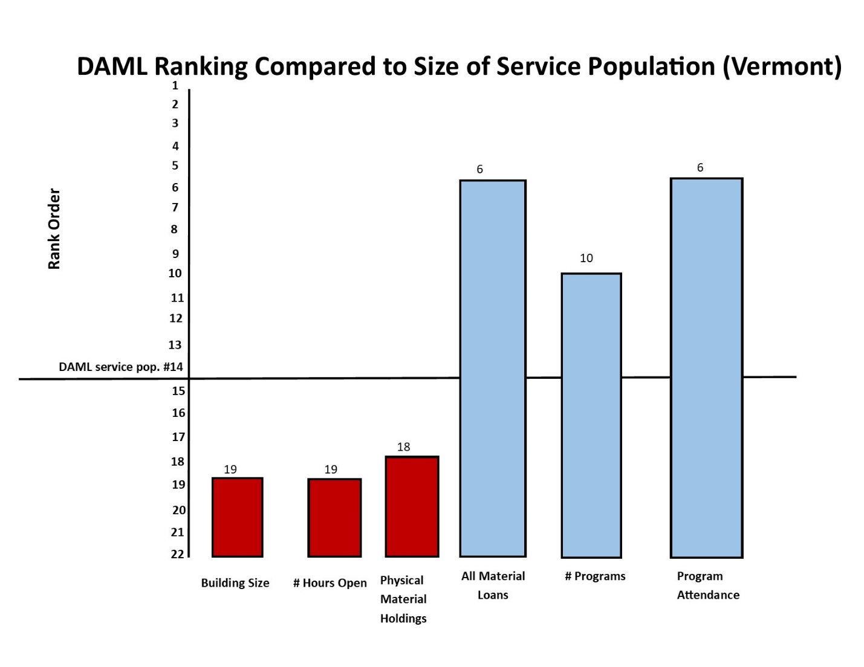

For More Information
Please contact the library if you have questions or comments on this plan. The library’s past strategic plans are available for review and provide historical information beyond the scope of this plan.
Dorothy Alling Memorial Library
21 Library Lane, Williston, VT 05495
802-878-4918, marti@williston.lib.vt.us

About How We Gathered Information
“Harwood Institute and ALA Announce Groundbreaking Initiative.” Turn Outward, Harwood Institute, January 29, 2013, www.theharwoodinstitute.org/news/2013/01/harwood-institute-and-ala-announce-groundbreaking-initiative.
“Turning Outward Resources for Libraries.” Community Relationships, American Library Association, January 13, 2014. www.ala.org/tools/librariestransform/libraries-transforming-communities/resources-for-library-professionals.
“Ask Exercise.” American Library Association, www.ala.org/tools/sites/ala.org.tools/files/content/Ask%20Exercise.pdf
“Planning for Results Library Service Responses.” Library Research Service, Colorado State Library: Colorado Department of Education, www.lrs.org/documents/cor/PFRsvcresponses.pdf

About Town of Williston
“Quick Facts: Williston town, Chittenden County, Vermont.” United State Census Bureau, 2017 www.census.gov/quickfacts/willistontownchittendencountyvermont
“Vermont Population Publications.” Vermont Population Estimates and Census Data, Vermont Health Statistics & Vital Records, January 1, 2013 – December 1, 2017, www.healthvermont.gov/health-statistics-vital-records/vital-records-population-data/vermont-population-estimates
“Vital Statistics Annual Reports.” Reports and Maps – Statistics By Year, Vermont Health Statistics & Vital Records, August 1, 2014 – March 13, 2018, http://www.healthvermont.gov/health-statistics-vital-records/vital-records-population-data/vital-statistics-reports-and-maps
“Chapter 2 – 50 + Years Of Planning: Williston’s Evolving Vision.” 2016-2024 Williston Comprehensive Plan, Planning and Zoning Department – Town of Williston, VT, August 22, 2017, https://www.town.williston.vt.us/vertical/sites/%7BF506B13C-605B-4878-8062-87E5927E49F0%7D/uploads/Table_of_Contents(1).pdf

About Dorothy Alling Memorial Library
“Vermont Public Library Statistics.” Public Library Statistics, Vermont Department of Libraries: Agency of Administration, www.libraries.vermont.gov/services/news/public_statistics

